

/*

program name:perfect number

*/

#include<stdio.h>

int main()

{

int no,sum=0;

printf("Entern a number:");

scanf("%d",&no);

for (int i=1;i<no;i++){

if (no % i==0)

sum+=i;

}

if(sum==no)

printf("%d is a perfect number\n",no);

else

printf("%d is not perfect number\n",no);

return 0;

}

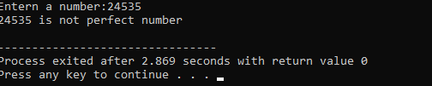**Output:**